From: https://medium.com/@caityjohnstone/all-of-these-russia-escalations-were-planned-years-ago-c3e5ad7e20f9
Caitlin Johnstone
Rogue journalist. Bogan socialist. Anarcho-psychonaut. Guerilla poet. Utopia prepper.
Apr 14, 2018

All Of These Russia Escalations Were Planned Years Ago
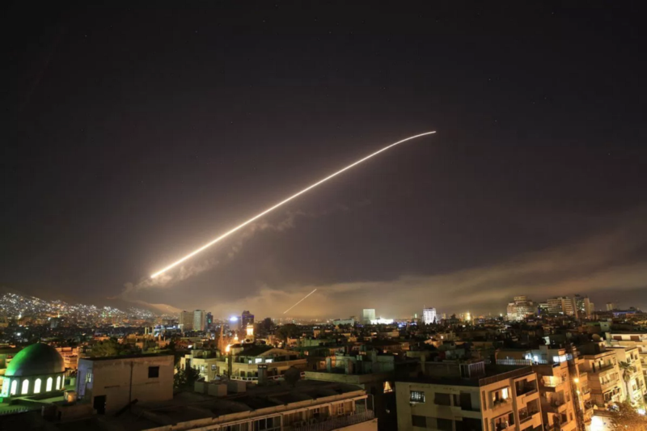
Ever since Trump took office last year his mainstream opposition has been giving us daily reminders that “THIS. IS. NOT. NORMAL.” on social media and wherever they can find a platform. The idea, apparently, is that Trump’s presidency is some sort of extraordinary, unprecedented evil, and we mustn’t “normalize” it or else we’ll forget how to get back to what normal is.
Thing is, the “normal” that they are trying to get back to has never existed. It’s a lie.
Which is why Trump’s rank-and-file opposition are running around like they’re on a bad acid trip and swinging at shadows in a state of manic disorientation with vagina hats on their heads.
The “THIS. IS. NOT. NORMAL.” sentiment on social media is typically a response to some new revelation related to the Russiagate conspiracy theory or the Trump administration’s attempt to push back on it. These McResistance ejaculations arise from the delusion that prior to January of last year, America was a functioning democracy that operated more or less the way they were taught about in grade school, wherein the government more or less told the truth, media outlets painted a more or less accurate picture of what the world is like, and everything was more or less stable.
And of course nothing could be further from the truth. The United States is a corporatist oligarchy ruled by a loose collaboration between plutocrats and defense/intelligence agencies in which ordinary people have virtually no say and the mass media exists to prevent everyone from realizing it. This oligarchy is built upon a power structure that is fast approaching post-primacy, and it will do things that are absolutely unthinkable to the “THIS. IS. NOT. NORMAL.” crowd in order to retain dominance.
This includes deceiving the entire western world about what is happening in Syria and Russia.
US, French and British forces bombed the Syrian government yesterday in response to an alleged chemical weapons attack that was very clearly not what we’re being told. There are repeated instances of children’s bodies being posed to elicit sympathy and outrage, fake photos of children receiving medical care, and testimony from purported witnesses that the narrative was deliberately and dishonestly manipulated on the scene to make cases of smoke inhalation look like people recovering from a chemical weapons attack. Jaysh al-Islam, the terrorist faction in control of Douma at the time, was clearly involved in a propaganda effort against the Assad government marketed to a western audience.
We aren’t allowed to say this, by the way. Used to be that you’d get shouted down by establishment loyalists for suggesting that the government might have staged a false flag. Now you even get shouted down by establishment loyalists for suggesting that an actual, literal terrorist group staged a false flag. That’s how stupid the propaganda machine has made everyone.
And they went ahead with the attack. In spite of all the gaping plot holes, the western empire rained dollars' worth of explosives down upon Syrian soil to the thunderous applause of establishment loyalists on both sides of the aisle. The evidence that they are giving us for the basis of this attack is laughable; the “proof” French President Macron had consists of garbage open-source information of the sort Atlantic Council propaganda firm Bellingcat might put out, and the way the attack was conducted makes it apparent that the chemical weapons facilities it claimed to have attacked weren’t there at all.
The rhetoric from this administration has been more unequivocal than ever that we can absolutely expect more aggressive acts of war if there are any more chemical weapons false flags, which of course in a region crawling with known terrorist factions who understand propaganda and have a vested interest in overthrowing Assad is a great way to guarantee more false flag chemical weapons attacks. Nikki Haley could not have made this clearer with her comment to the UN Security Council, “I spoke to the president this morning and he said if the Syrian regime uses this poison gas again, the United States is locked and loaded. When our president draws a red line, our president enforces the red line.”
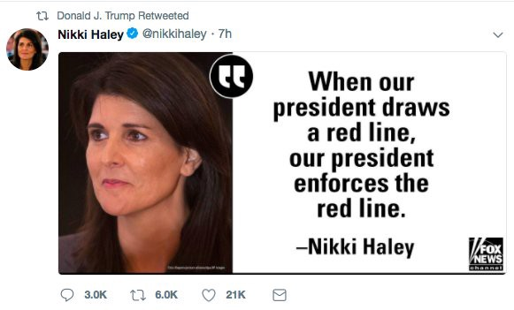
So there’s no reason to believe that was the end of this administration’s attacks on the Syrian government, and there’s every reason to believe we’ll see a lot more.
In response to this attack, Russian Ambassador Anatoly Antonov stated that “such actions will not be left without consequences,” and that all responsibility for those consequences “rests with Washington, London and Paris.” Putin strongly condemned the attack.
Those of us ruled by the western empire are meant to hate Russia while simultaneously being acutely aware that it is only Russian cool-headedness that is saving us from a world war right now. But whether they admit it or not, anyone paying attention to this situation is wondering how far Russia can be pushed. How many more acts of aggression facilitated by blatant false flags will it take before Russia responds aggressively? How much can you poke the bear before it bites?
These are questions that have an answer, and the people at the steering wheel of this empire seem determined to find that answer.
And this was planned. All of it was planned in advance.
Ordinary Americans rarely thought about Russia prior to 2016. It certainly wasn’t a nation the rank-and-file west was thinking and talking about constantly. Then all of a sudden, through nothing other than the power of sheer narrative, it’s become an omnipotent, insidious force in the eyes of the public with the ability to infiltrate and overturn democracies all around the world and influence major events everywhere from the US to the UK to Syria. The Facebook ads could have been a second-page story for one day and nobody would have cared. The DNC hack, even if it happened, could have disappeared from the news after a day or two and it would have gone unnoticed. But because the mass media propaganda machine has been hammering Russia, Russia, Russia all day every day, it now seems perfectly reasonable to believe that Putin is behind every major event in the world; perfectly reasonable for so much of the Syria saber rattling to be targeted not at Damascus but at Moscow.
This anti-Russia propaganda campaign started in 2016 not because of the 2016 election, but because that was when a Russia hawk was scheduled to replace Barack Obama in office. [Wow!]
In 2014, to the notice of hardly anybody, the US staged a coup in Ukraine. Here’s an article from the beginning of 2015 about Hillary Clinton promoting a very anti-Russia position on Ukraine which contrasted sharply with Obama’s, and here is an article from June 2015 about people on both sides of the aisle being made nervous by Clinton’s Russia hawkishness. This was long before Russia was a blip on the radar in American consciousness, but the then-heir apparent to the throne was already gearing up for escalations with that nation.
The Intercept‘s Glenn Greenwald and Zaid Jilani recently article about something I’ve been yelling about for a while now: the fact that the Trump administration, despite all the allegations of Russian collusion, is actually vastly more hawkish toward Russia than Obama ever was. After his surprise win Trump was taken in, shown around, and then pressured by Washington insiders and/or by the political pressures of Russiagate into doing the thing Hillary Clinton had been planning on doing: greatly escalating the new cold war. Obama’s refusal to fully collaborate with ramping up tensions with Russia was scheduled to be rectified by Clinton, and since they didn’t get her they’re getting the same thing from Plan B.
This was all planned. A desperate, declining empire with a need to sabotage the rise of nonconforming nations and their allies has been planning for years to either squeeze Russia like a python until it taps out and moves out of the way, or until it fights back and is crushed militarily. That’s the plan, and since the life of the empire depends upon its success, they’ll do literally anything to make sure it succeeds. This includes lying to the world to an extent that has never before been seen in modern history.
The US-centralized Empire is not normal. It never has been. Nothing about this is natural or healthy, and you couldn’t ask for a better sign of this than our close proximity to world war with a nuclear superpower. We’ve got to shuck off these parasites and find a healthier way to function as a species.
________________________
Internet censorship is getting pretty bad, so best way to keep seeing my daily articles is to get on the mailing list for my website, so you’ll get an email notification for everything I publish. My articles and podcasts are entirely reader and listener-funded, so if you enjoyed this piece please consider sharing it around, liking me on Facebook, following my antics on Twitter, checking out my podcast, throwing some money into my hat on Patreon or Paypal, or buying my new book Woke.

Bitcoin donations:1Ac7PCQXoQoLA9Sh8fhAgiU3PHA2EX5Zm2



Caitlin Johnstone
Rogue journalist. Bogan socialist. Anarcho-psychonaut. Guerilla poet. Utopia prepper.

